

Stories from Lake Chelan:
Opportunities to restore and steward our lake into the future.
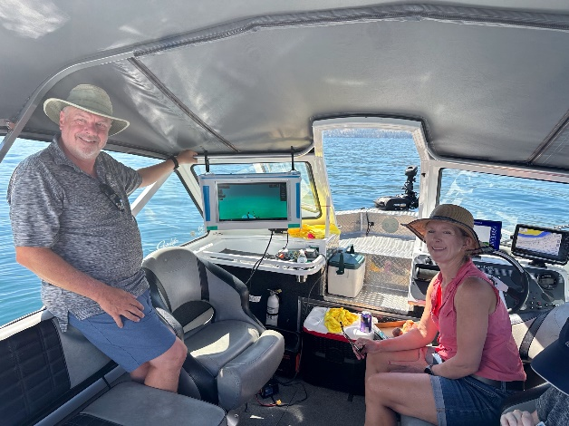
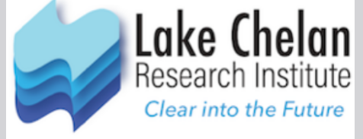

7pm, Thursday, Nov 20, 2025
Join us at Ruby U for an informative evening. Hear the latest from the Lake Chelan Research Institute about geological, environmental, and human stories from the Lake Chelan Watershed. Learn about potential threats to the lake's ecology and opportunities to restore and steward the lake into the future. You will see aerial and underwater photography by Cashmere's Steven Gnam (National Geographic, Crown of the Continent). Lake Chelan Research Institute's Anna Galipeau and Phil Long will be presenting new perspectives on the ecological treasure that is Lake Chelan.

Ruby U presentations are designed to inform, educate, and challenge the understanding of ourselves, our community, and our valley now and into the future.
Free Admission. Doors open at 6:30 pm.
Ruby Theatre, 135 E Woodin Ave, Chelan, WA 98816 ww.rubytheatre.com 509-687-3210

