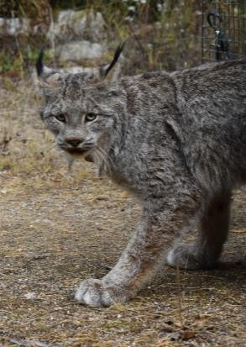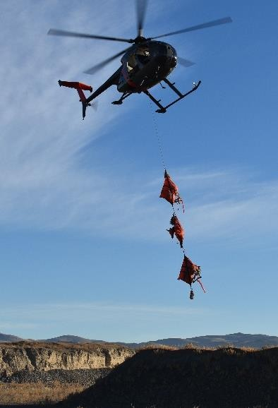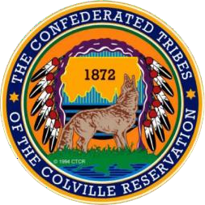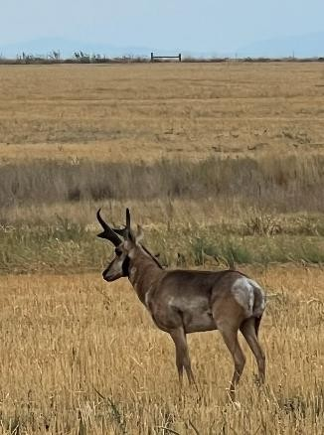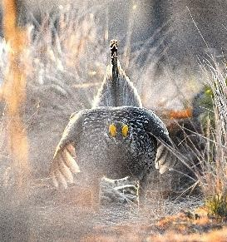

“CTCR Wildlife Reintroductions & Management”
Thursday, January 22, 2026
7 pm to 8:30 pm
Sam Rushing, biologist with the Confederated Tribes of the Colville Reservation, will be talking about the work done to reintroduce and manage of the Canadian Lynx, Pronghorn, Columbian Sharp-tailed grouse and Bison on the Colville Reservation and other areas in North Central Washington.

Free Admission. Doors open at 6:30 pm.
Ruby Theatre, 135 E Woodin Ave, Chelan, WA 98816
Ruby U presentations are free programs designed to inform, educate, and challenge the understanding of ourselves, our community, and our valley now and into the future www.rubytheatre.com 509-687-3210

