

"Perspectives on Housing"
Thursday, December 11, 2025

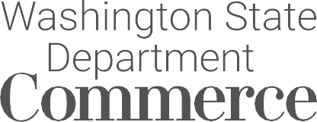
7 pm to 8:30 pm

HOUSING AUTHORITY OF CHELAN COUNTY &
CITY OF WENATCHEE

Emily Stone, Senior Policy Advisor, Washington State Department of Commerce and Vicki Carr, Housing Authority of Chelan County & City of Wenatchee will present perspectives of the critical housing issues affecting our valley. The speakers will address housing goals, programs, and local challenges. They will discuss ways in which local residents can take action to support meeting our housing needs.
Ruby U presentations are designed to inform, educate, and challenge the understanding of ourselves, our community, and our valley now and into the

future.

Free Admission. Doors open at 6:30 pm.
Ruby Theatre, 135 E Woodin Ave, Chelan, WA 98816

